JavaScript Lab Session 04
Making Decisions in Code: if-else & switch-case

Part 0 — From Ternary to if-else (10 min)
In Lab 2, you used the ternary operator to make small decisions. Today you will learn a bigger, clearer way to do this: if-else. It does the same job, but it is easier to read — especially when you want to run more than one line of code.

Task 0.1: Run both examples above. Do they print the same answer? Write one line: which style is easier for YOU to read?

The OLD way (ternary) — from Lab 2
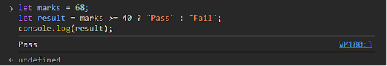
The NEW way (if-else) — today's topic
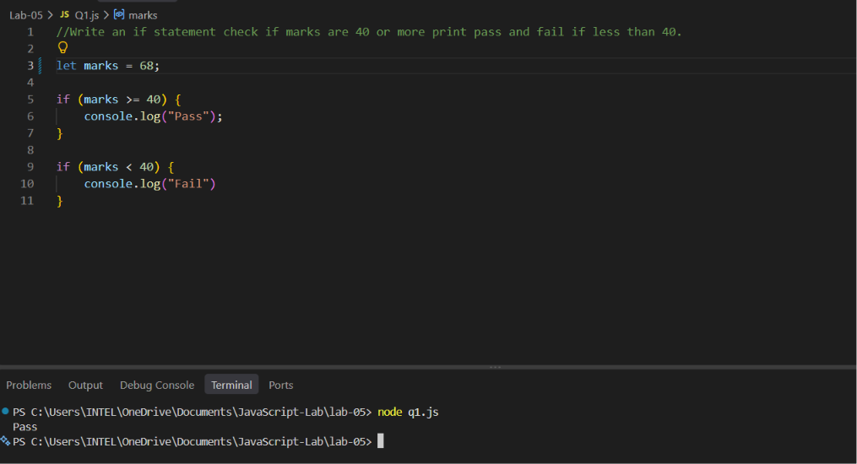

Answer: Both examples give the same answer, “Pass” but I find if-else easier to read because the condition and both possible outcomes are clearly separated.

Part 1 — The if Statement (15 min)
An if statement checks a condition. If the condition is true, the code inside { } runs. If it is false, nothing happens — the code is simply skipped.

Task 1.1: Write an if statement. Check if marks are 40 or more. If yes, print "You passed!". Test it with two different marks values.
Test 1
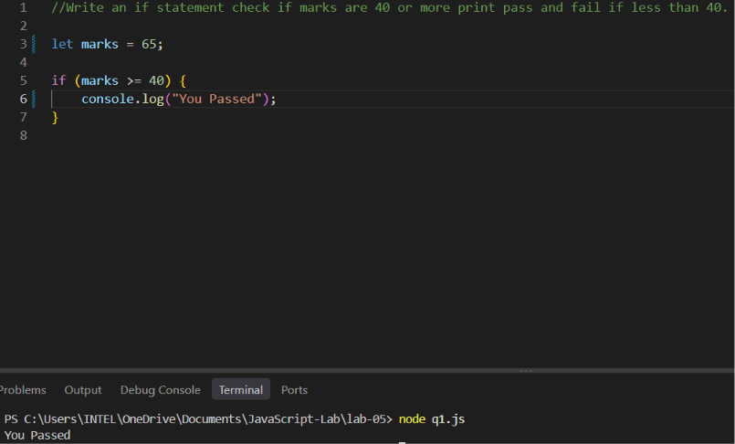

Test 2
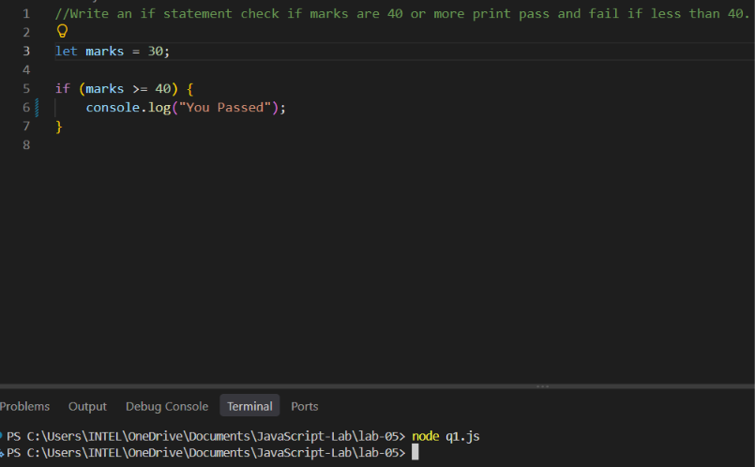
Task 1.2 (Fun Task) — "Can You Watch This Movie?": Write an if statement. If age is 18 or more, print "You can watch this movie". Test it with 3 ages: a child, a teenager, and an adult.

Child
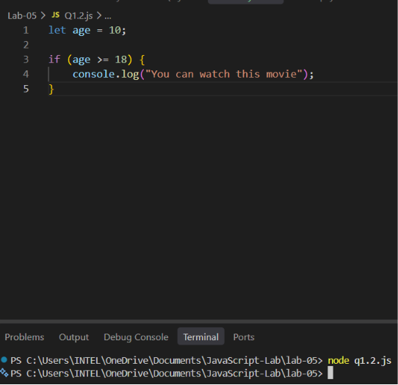

Teenager
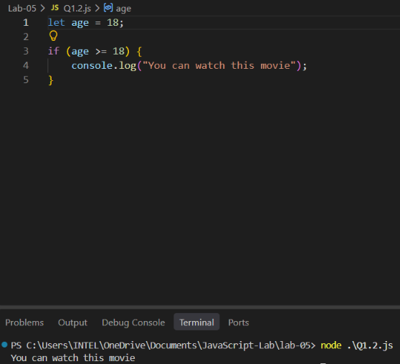
Adult
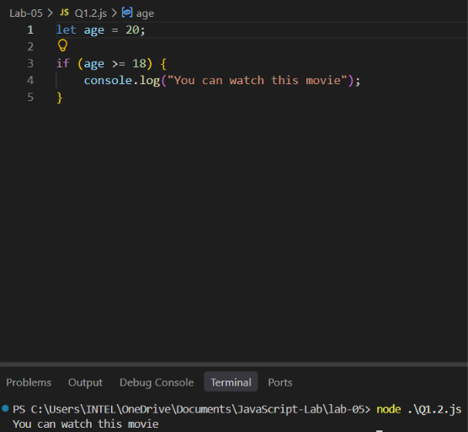

Part 2 — if-else: Two Paths (20 min)
if-else gives your code TWO paths. One path runs when the condition is true. The other path runs when it is false. One of the two ALWAYS runs.

Task 2.1: Write an if-else. Check if a number is even or odd. Test it with 3 different numbers.
Test 1
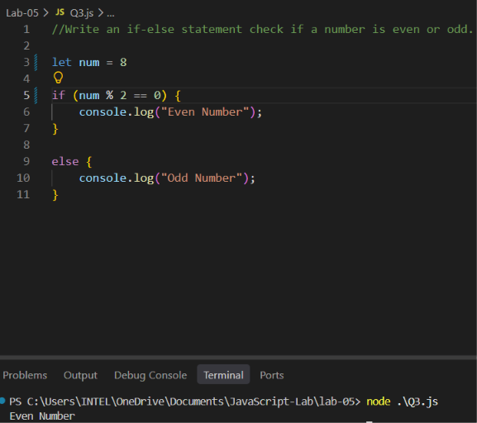
Test 2
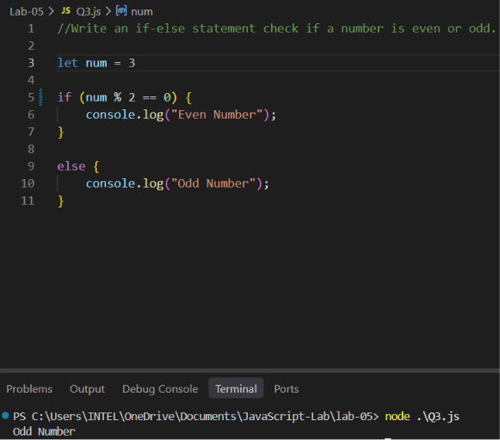

Test 3
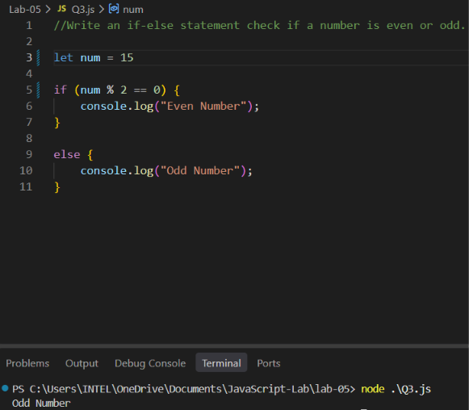

Task 2.2 (Fun Task) — "ATM PIN Checker": Store a correct PIN, like 1234, in one variable. Store a guess in another variable. If the guess matches, print "Access Granted". If not, print "Access Denied". Test once with the right PIN, and once with a wrong PIN.

Wrong PIN
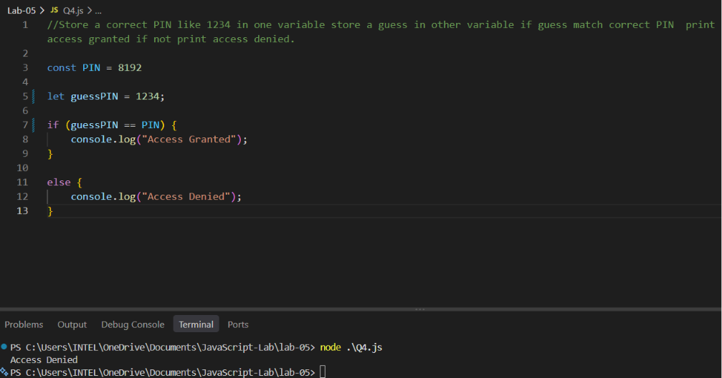

Right PIN
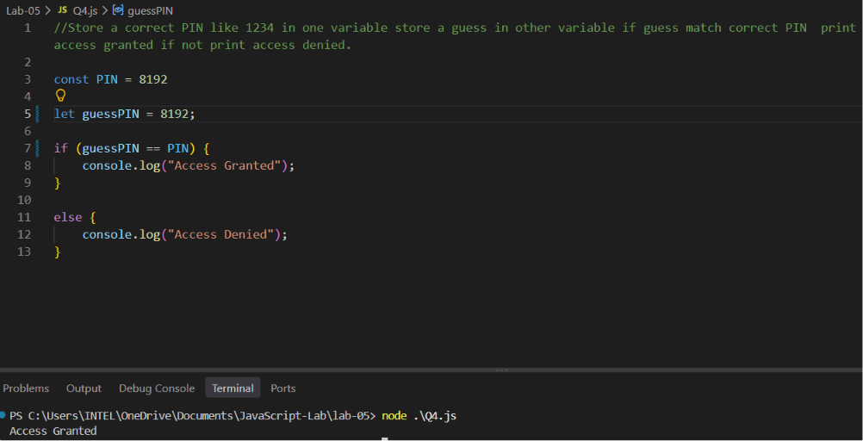

Task 2.3 — Compare with Lab 2: Find your "Pass/Fail" ternary code from Lab 2. Rewrite it using if-else instead. Which one do you like better? Write one line.

Ternary version
If-else version
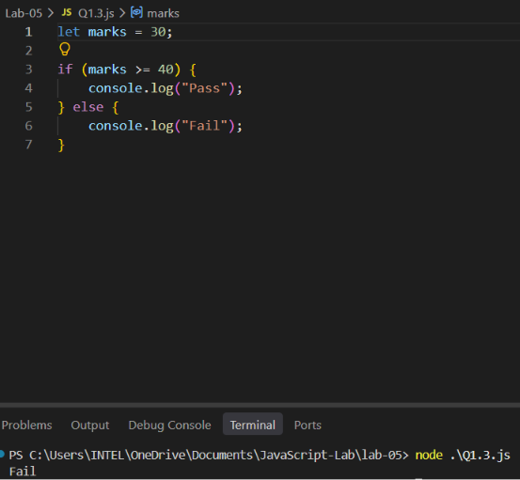

Part 3 — if-else-if: More Than Two Paths (25 min)

Task 3.1 (Fun Task) — "Movie Ticket Price": You built this in Lab 2 using ternary. Build it again, now with if-else-if: age < 5 → "Free", age < 12 → "Rs. 100", age < 60 → "Rs. 250", else → "Rs. 150". Test with 5 different ages.

Test 1
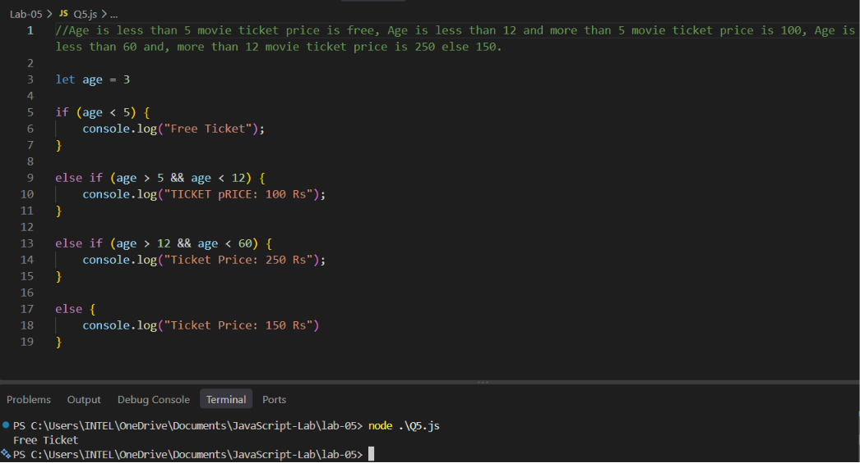

Test 2
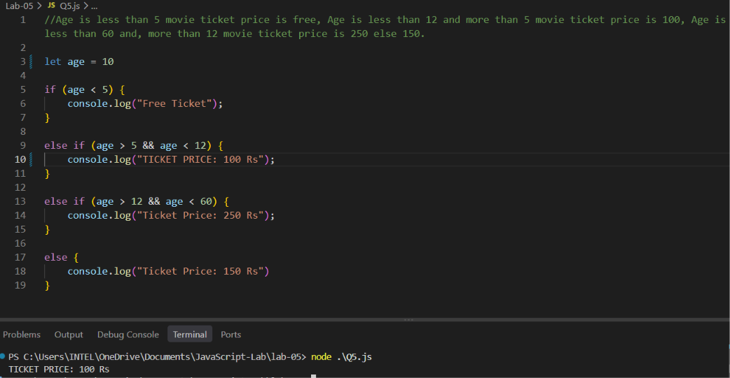
Test 3
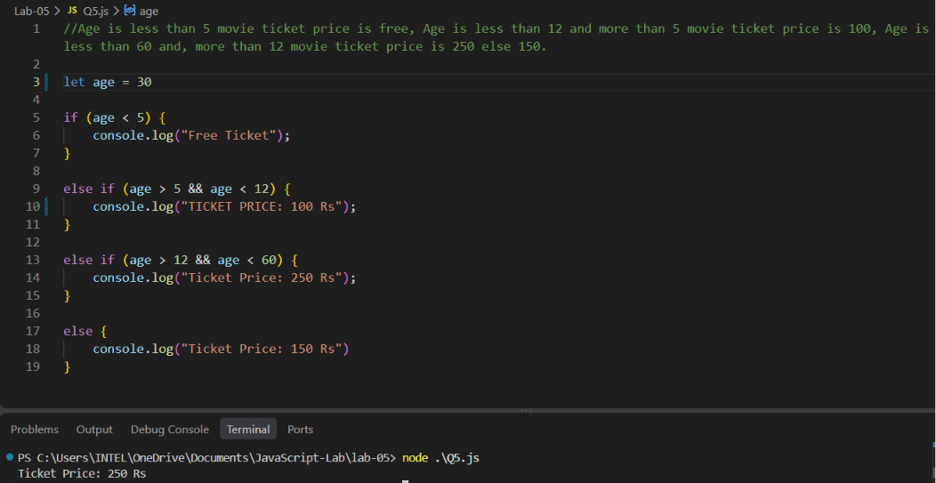

Test 4
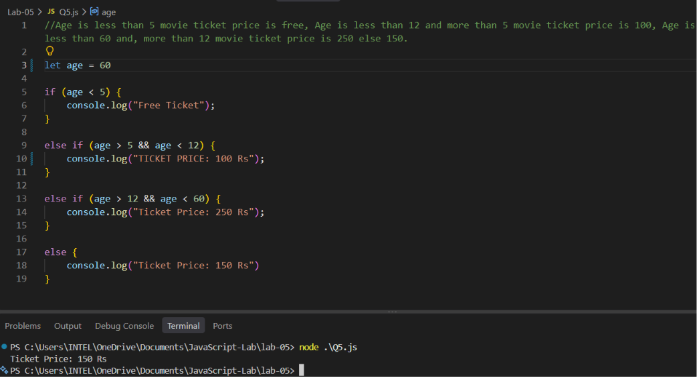

Test 5
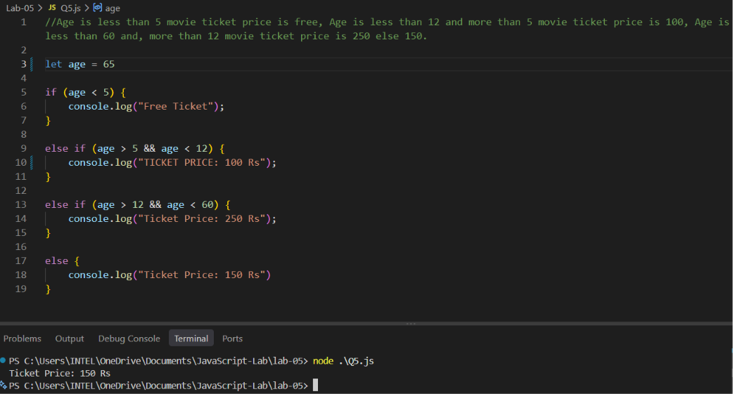

Task 3.2 (Fun Task) — "Weather Advice Bot": Write an if-else-if chain for a temperature variable: above 35 → "It's hot! Drink water.", above 20 → "Nice weather!", above 10 → "A bit cold. Wear a jacket.", else → "Very cold! Stay warm." Test with 4 different temperatures.

Test 1
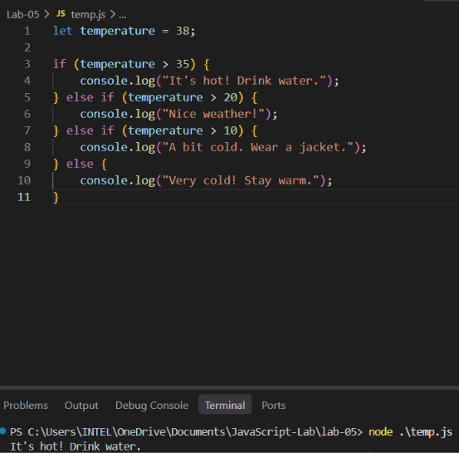
Test 2
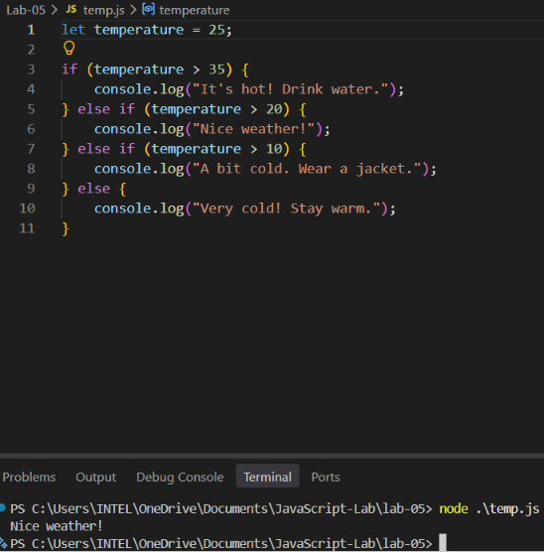

Test 3
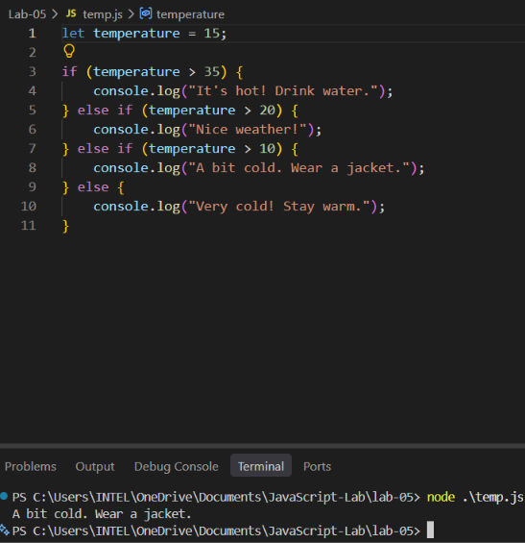

Test 4
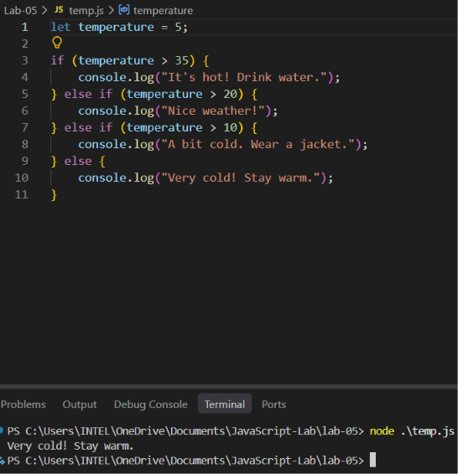

Part 4 — switch-case: A Clean Way for Many Choices (25 min)

Task 4.1: Write a switch-case for all 7 days (1 to 7 → Monday to Sunday). Add a default case for any number outside 1–7.
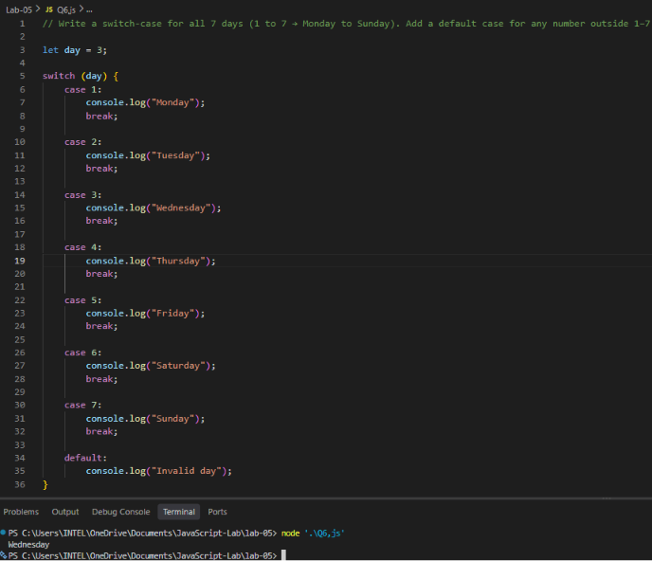

Task 4.2 (Fun Task) — "Mood Emoji Switch": Make a variable called mood, with a value like "happy", "sad", "angry", or "tired". Use switch-case to print a short matching message for each mood, plus a default message for any other mood.
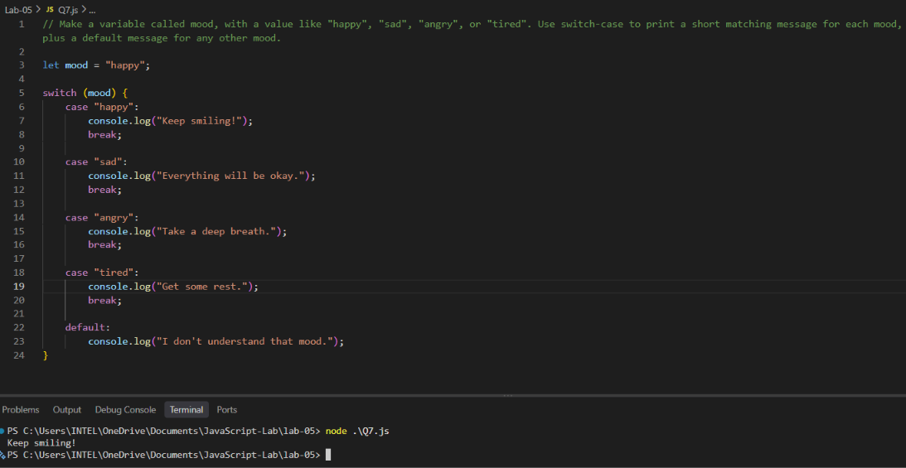

Task 4.3 — The Missing break Experiment: Copy your Task 4.1 code. Remove ONE break on purpose. Run it. What happens? Put the break back. Write 2 lines explaining what break does, in your own words.
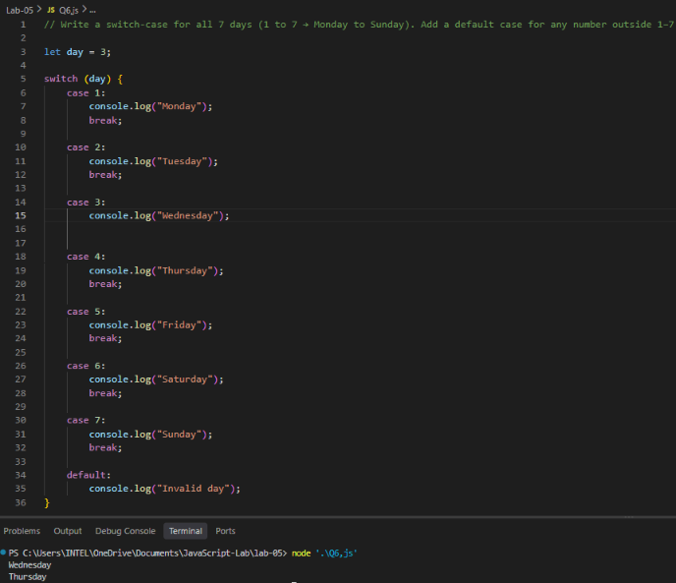
Answer: break stops the execution of the switch after the matching case. Without break, JavaScript continues executing the following cases, which is called fall-through.

Part 6 — Debugging Challenge (15 min)

Task 6.1: For each snippet: run it, find the bug, and fix it. In your lab record, write what was WRONG and what you CHANGED. (Hint: Snippet 1’s bug is one you have seen before, in Lab 1 or 2!)

Snippet 1
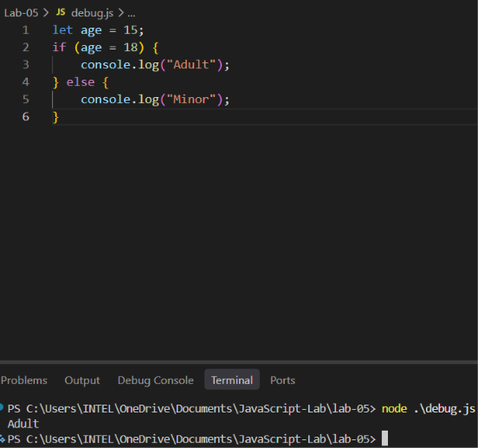

Wrong: it gives the wrong answer cause age = 18, = is the assignment operator it assigns 18 to age but we want to compare age with 18.

Correct: We use == to compare, changed age = 18 to age == 18.
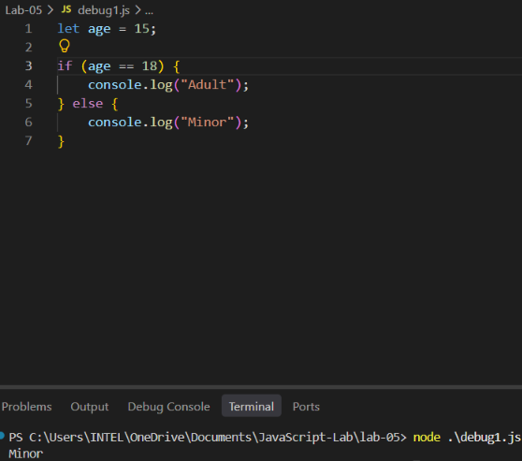

Snippet 2
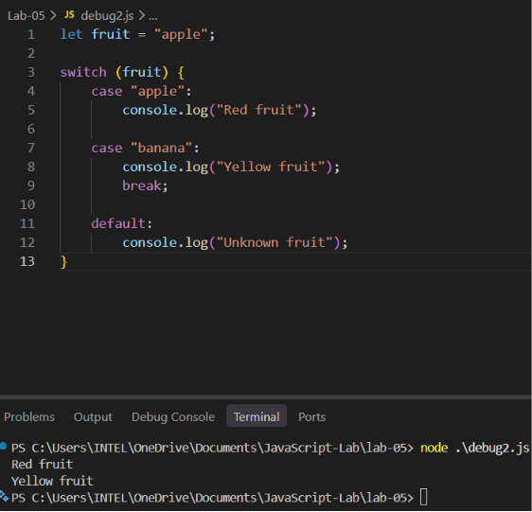

Wrong: The break statement was missing after the "apple" case.
Correct: Added break after the "apple" case to prevent fall-through.
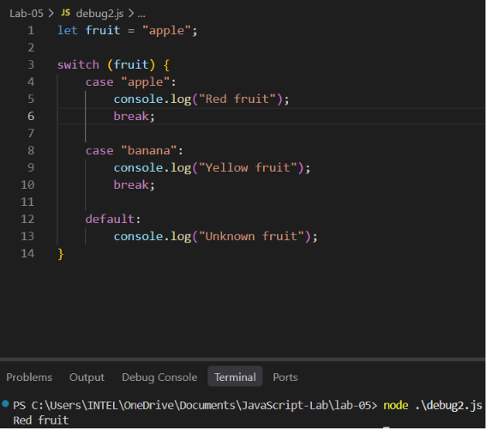

Snippet 3
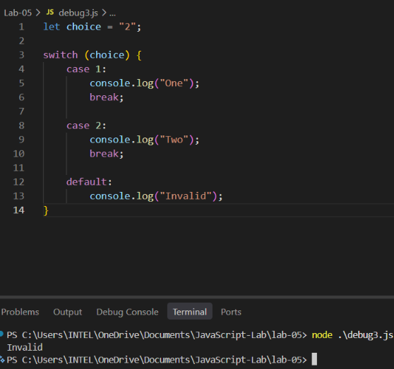

Wrong: choice was stored as a String "2" while the cases use Numbers 1 and 2.

Correct: Change String to Number “2” to 2
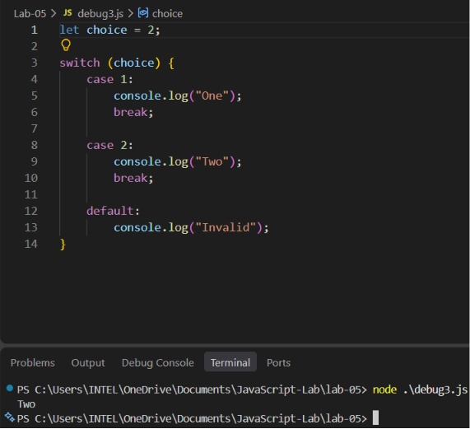

Part 5 — Mini Project: Build a Simple ATM Machine (35 min)
This is today’s big, fun project. A real ATM checks your PIN first (if-else), then gives you a
menu of choices (switch-case). You will build exactly that.

Requirements:
1. Store a correct PIN (Number) and an entered PIN (Number).
2. Store an account balance (Number).
3. Use if-else: if the entered PIN matches the correct PIN, continue. If not, print "Wrong PIN.
Access Denied." and stop there.
4. If the PIN is correct, store a choice (Number): 1 = Check Balance, 2 = Withdraw, 3 = Deposit.
5. Use switch-case on the choice: case 1 → print the current balance. case 2 → store an
amount to withdraw, then use an if-else INSIDE this case: if the amount is more than the
balance, print "Insufficient funds"; else, subtract the amount and print the new balance. case 3
→ store an amount to deposit, add it to the balance, and print the new balance. default → print
"Invalid choice".
6. Test your ATM with AT LEAST 3 situations: (a) a wrong PIN, (b) a correct PIN with a withdrawal
bigger than the balance, (c) a correct PIN with a successful deposit or withdrawal.

Sanity check for your own testing
With PIN 1234 and balance 5000: entering the wrong PIN 9999 → "Wrong PIN. Access Denied."
Entering the correct PIN and trying to withdraw 7000 → "Insufficient funds." Entering the correct PIN
and depositing 2000 → new balance 7000. Use these numbers to check your own program works
before trying your own values.

Test 1 — Wrong PIN
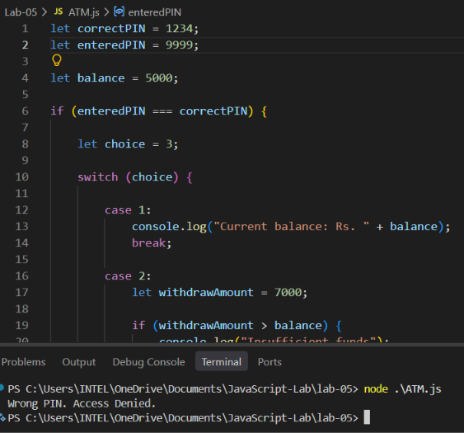

Test 2 — Correct PIN and Withdrawal
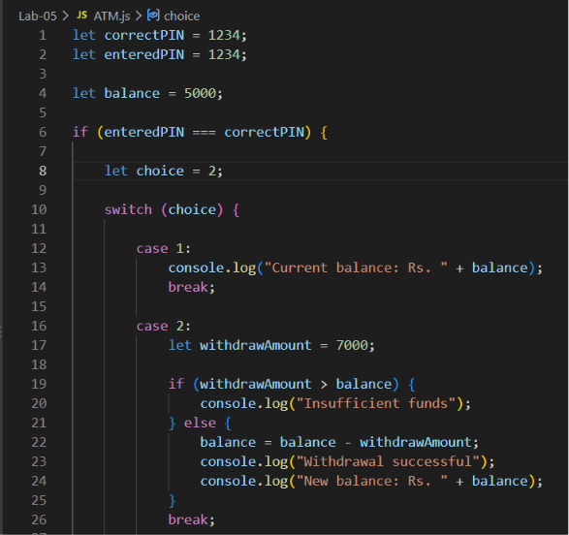

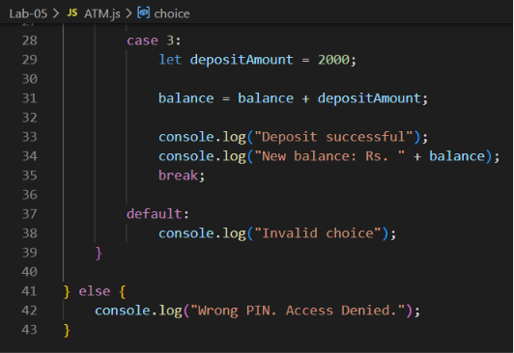

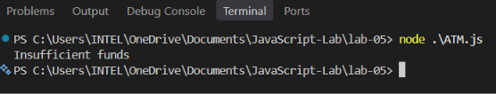
Test 3 — Successful Deposit
